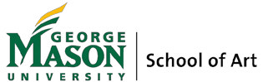

MFA Inquiry Form

Thank you for your interest in our MFA program. Please provide your information as requested below.

The School of Art MFA program requires a high degree of capability and commitment. Admission is highly selective. For consideration, applicants must hold a BA or BFA from an accredited college or university or a diploma from a four-year accredited professional art school. Our program seeks exceptionally self-motivated candidates whose thinking and work engages and communicates critically and creatively with the world. Applicants should have a thoughtful understanding of art history, contemporary art and theory, and have developed a body of work that demonstrates an active, current studio practice. Deadline for application is January 15. Send completed form to Peggy Feerick, Graduate Coordinator, pfeerick@gmu.edu

Name: E-mail:
Street Address: _________________________________________________________________
City: State: Zipcode:
Home Phone: Cell: Work:

List previous academic institutions:
Institution Major/Minor Degree Earned Year Obtained

Describe your interest in pursuing an MFA, and your intended studio concentration:

Please provide a brief history of your academic and/or professional endeavors:

Describe your current body of work and the ideas that drive it:

How did you hear about the GMU MFA program? Why this MFA program?

